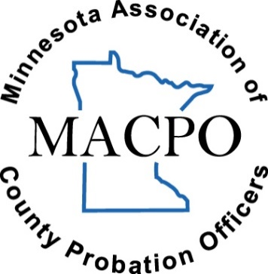
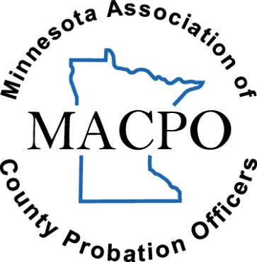
MACPO
Academic Memorial Scholarship
Application Form
ELIGIBILITY: Must be current MACPO member to apply for scholarship . . . open to current undergraduate & graduate students.
APPLICATION PROCEDURE: (Fully) complete the form and email to Emily Ostlund:
emily.ostlund@goodhuecountymn.gov
** Applicants can insert new rows to table(s) for additional space as needed. **

PERSONAL DETAILS:
Date (m/d/yr):
First Name: | Last Name: | Middle Initial:
Street Address: | Apartment/Unit #:
City: | State:
Zip Code: | Phone #:
Email Address:

EDUCATIONAL BACKGROUND
(High School):
INSTITUTION | GPA | ANTICIPATED GRADUATION DATE

EDUCATIONAL BACKGROUND
(College):
INSTITUTION | GPA | MAJOR | MINOR | Type of Student | (ANTICIPATED) GRADUATION DATE
Undergraduate Student

Graduate Student
Undergraduate Student

Graduate Student
Undergraduate Student

Graduate Student

PROFESSIONAL CERTIFICATIONS
(if none, then please write “n/a”):
TITLE | DATE OBTAINED | WHERE OBTAINED

DESCRIBE YOUR INVOLVEMENT IN EXTRA-CURRICULAR ACTIVITIES IN HIGH SCHOOL AND COLLEGE
(If none, then please write “n/a”:

WORK EXPERIENCE (MOST RECENT FIRST)
(if none, then please write “n/a”):
EMPLOYER | DATES OF EMPLOYMENT | POSITION HELD | REASON FOR LEAVING / STILL EMPLOYED

REFERENCES
(Minimum of three references must be included):
NAME | JOB | RELATIONSHIP | PHONE # | EMAIL ADDRESS

PLEASE ANSWER THE FOLLOWING QUESTIONS TO THE BEST OF YOUR ABILITY
ANY UNANSWERED QUESTIONS WILL RESULT IN AN INCOMPLETE APPLICATION:

- Explain the importance of the Criminal Justice/Corrections profession in today’s society?

- What is your career goal and why have you chosen this path?

- Have you been involved in any internships, associations, and/or volunteer work? If yes, please describe such involvement in detail.

- What is the significance of MACPO in the field of Corrections?

- Why are you a good candidate to receive this award?

HOW WILL THIS SCHOLARSHIP HELP YOU?
IN 300 WORDS OR LESS:
How will this scholarship assist you in preparation for your career?

